KARNATAKA VETERINARY ANIMAL AND FISHERIES SCIENCES UNIVERSITY, BIDAR

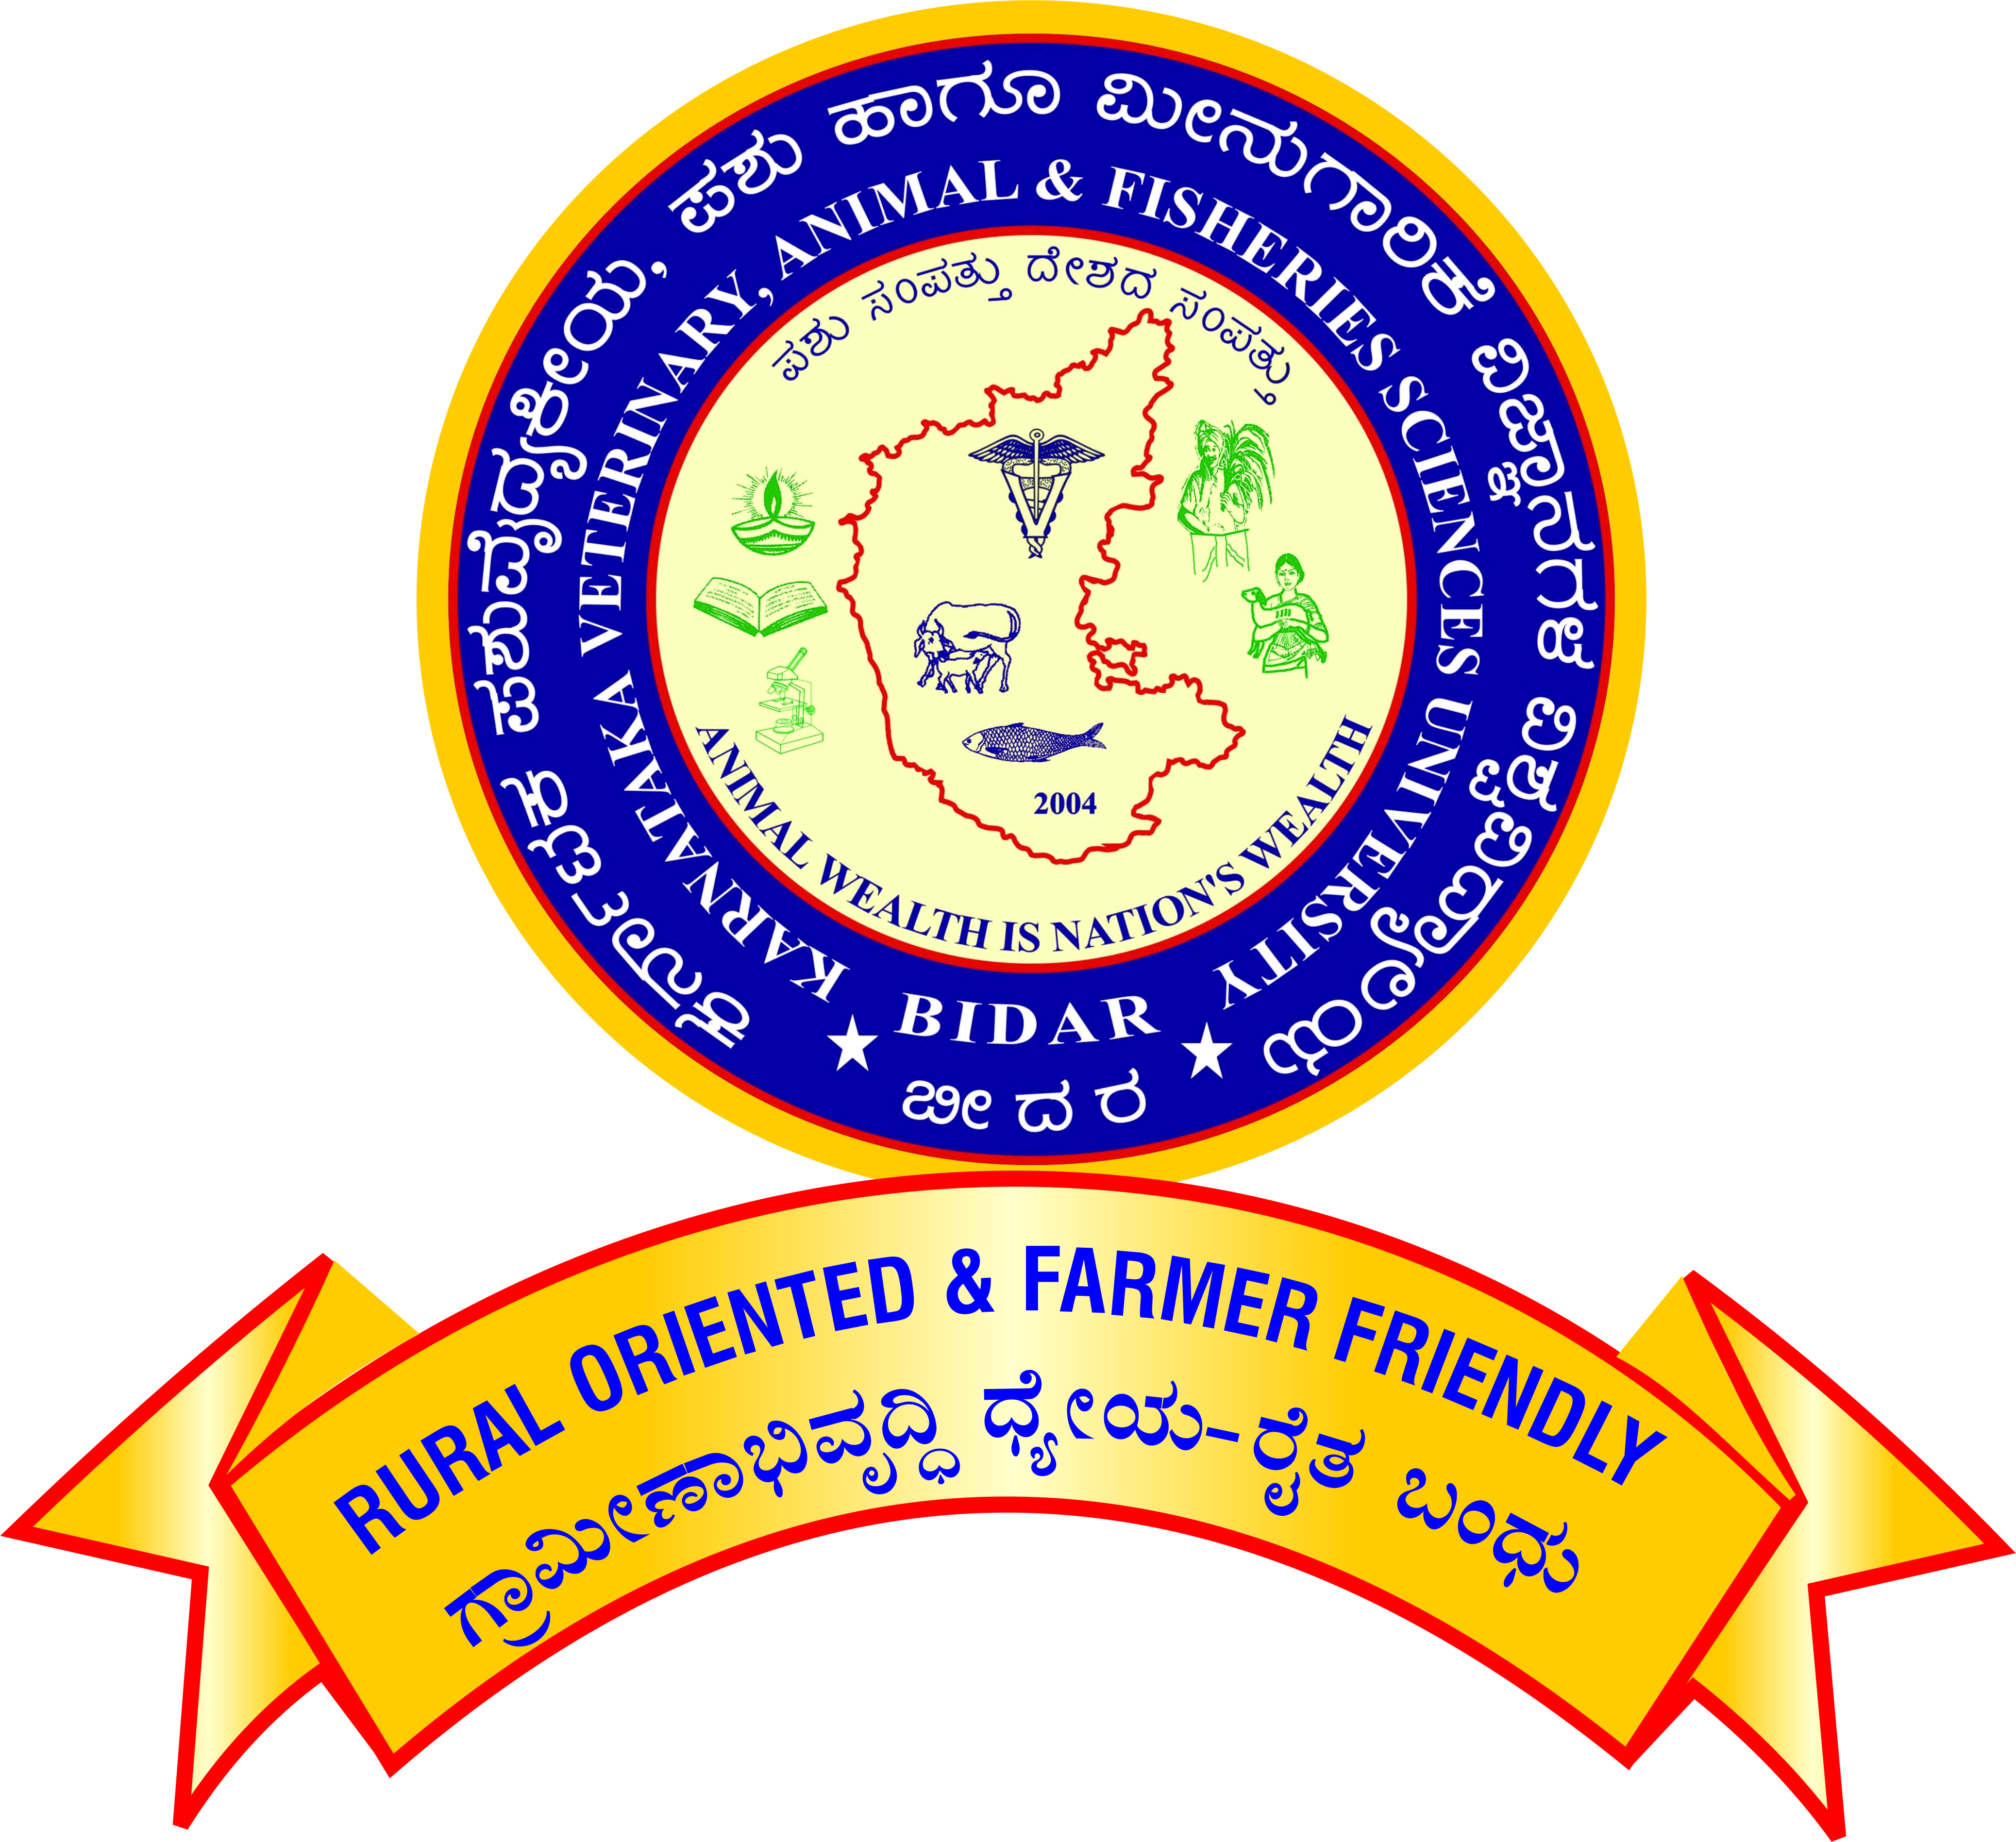

APPLICATION FOR PROMOTION OF TEACHERS UNDER CAREER ADVANCEMENT SCHEME – 2016

For promotion from Professor (Academic Level 14) to Senior Professor (Academic Level 15)

[Note: All the claims shall be supported by relevant letters/certificates issued by concerned dean/controlling officer]

Affix self-attested photo.

1. Name :

2. Designation and Address :

3. Name of the Department/ :

Section/Unit/Scheme

4. Date of Birth :

5. Academic Qualification :

|  |  |  |  |  |  |
| --- | --- | --- | --- | --- | --- |
| **Degree / Diploma** | **Discipline/**  **Subject** | **University/ Board** | **Month/**  **Year of passing** | **Marks/ OGPA**  **obtained** | **Remarks** |
|  |  |  |  |  |  |

6. Date on which Ph.D. degree Completed :

7.

|  |  |
| --- | --- |
| 1. Date of joining duty at KVAFSU, BIDAR as Professor in the Academic Level 14/AGP 10000 | : |

8. Date of completion of 10 years’ service :

in the cadre of Professor

(Academic Level 14/AGP 10000)

**9. Employment record:**

1. Service within the university

|  |  |  |  |  |  |
| --- | --- | --- | --- | --- | --- |
| Place of work with full address | Designation / Post held | Scale of Pay | Period | | Nature of duties |
| From | To |
|  |  |  |  |  |  |

b. Service outside the university

|  |  |  |  |  |  |
| --- | --- | --- | --- | --- | --- |
| Place of work with full address | Designation / Post held | Scale of Pay | Period | | Nature of duties |
| From | To |
|  |  |  |  |  |  |

**10.** **Eligibility for Promotion**

1. Have you published a minimum of ten publications in the peer-reviewed journals or ICAR/UGC-listed journals during the assessment period?  **Yes/No**

If yes furnish details as follows and enclose copy of the same

|  |  |  |  |  |
| --- | --- | --- | --- | --- |
| **Sr. No.** | **Authors** | **Title of the publication** | **Year** | **Volume and page numbers** |
|  |  |  |  |  |

1. Whether the PhD/master’s degree has been successfully awarded to two candidates under his/her supervision during the assessment period? **Yes/No**

**If yes furnish the details**

|  |  |  |  |
| --- | --- | --- | --- |
| **S.No** | **I.D.No. and Name of the Ph.D/Master’s Student guided** | **Year of award** | **Specialization** |
|  |  |  |  |

## 11. Details of Work Performance:

## Areas in which the scientist/teacher made some mark including the specific Achievements in teaching/ research/Extension/corporate activities (administration and management) during the assessment period.

**A) Teaching:**

**a). Courses taught.**

**i) Bachelor level:**

|  |  |  |  |  |  |
| --- | --- | --- | --- | --- | --- |
| **Course title** | **Year & Class** | **Course No.** | **Cr.Hrs.** | **Semester** | **Independently or Jointly with** |
| Academic Year: | | | | | |
|  |  |  |  |  |  |

ii) **Master level:**

|  |  |  |  |  |  |
| --- | --- | --- | --- | --- | --- |
| **Course title** | **Year & Class** | **Course No.** | **Cr.hr** | **Semester** | **Independently or Jointly with** |
| Academic Year: | | | | | |
|  |  |  |  |  |  |

### iii) **Ph.D. level**:

|  |  |  |  |  |  |
| --- | --- | --- | --- | --- | --- |
| **Course title** | **Year & Class** | **Course No.** | **Cr.hr** | **Semester** | **Independently or jointly with** |
| Academic Year: | | | | | |
|  |  |  |  |  |  |

b). Guidance to PG students as Chairman of the Advisory Committee

1. Completed Masters Students :
2. Completed Ph. D. Students :

**c). Guidance to PG students as Member of the Advisory Committee**

1. Completed Masters Students :
2. Completed Ph. D. Students :

B). Research:

1. Externally funded projects

|  |  |  |  |  |  |  |
| --- | --- | --- | --- | --- | --- | --- |
| **Sl.**  **No** | **Title** | **Funding agency** | **Budget** | **Year of start** | **Year of completion** | **As PI /Co-PI** |
|  |  |  |  |  |  |  |

**Note:** The Project shall be completed/in operation and Funds must be released.

1. **Patents / varieties / prototypes / technologies developed / breeder quality seeds production**

i) As PI :

ii) As Co-PI :

1. **Monitoring of the research/extension projects such as RKVY and other GoI/GoK Projects (Other than Externally Funded Projects).**

|  |  |  |  |  |  |  |
| --- | --- | --- | --- | --- | --- | --- |
| **Sl.**  **No** | **Title** | **Funding agency** | **Budget** | **Year of start** | **Year of completion** | **Involved as** |
|  |  |  |  |  |  |  |

**C) Extension:**

1. Transfer of technologies (farm trails/ :

Field days/ Krishi Melas/ Demonstrations/

Exhibition/ Discussion meeting/ on-farm

Testing/ on campus official consultancy conducted.

1. Training programme organized:

* Duration: upto 1 week

i) As Coordinator :

ii) As Associate Coordinator :

|  |  |  |  |  |  |
| --- | --- | --- | --- | --- | --- |
| **Sl No** | **Title** | **Duration** | **Place and Date** | **Organized by** | **Coordinator/Associate Coordinator** |
|  |  |  |  |  |  |
|  |  |  |  |  |  |

* Duration: more than one week:

i) As Coordinator :

ii) As Associate Coordinator :

|  |  |  |  |  |  |
| --- | --- | --- | --- | --- | --- |
| **Sl No** | **Title** | **Duration** | **Place and Date** | **Organized by** | **Coordinator/Associate Coordinator** |
|  |  |  |  |  |  |
|  |  |  |  |  |  |

1. As Resource Person in the training Programme :

Number of Lectures:

|  |  |  |  |  |  |
| --- | --- | --- | --- | --- | --- |
| **Sl No** | **Place and Date** | **Type of Event** | **Title of Training** | **Topic Discussed** | **Organized by** |
|  |  |  |  |  |  |
|  |  |  |  |  |  |

1. Official Diagnostic visit to farmer’s fields:

/On-farm/ Units/Radio/TV talk/Expert

Service/ Consulting/Visitors extension

1. Feedback to research/ Contribution to Package of practices
2. Clinics/ Diagnostic/ Farm Work/ Head:

of EEC/ (Other than teaching)

# Published work during the assessment period

1. **Research Publications:**

|  |  |  |  |  |  |
| --- | --- | --- | --- | --- | --- |
| **Sl**  **No** | **Name of Author(s)**  **in order** | **Year** | **Title of the paper** | **Name of the journal**  **(Vol. No., issue no & page no)** | **NAAS Rating** |
|  |  |  |  |  |  |

1. **Professional Book published/Edited (Minimum of 64 pages-Only with ISBN No.)**
2. Recognized publishers
3. Chapters in standard books
4. Research / Extension bulletin
5. Research note /communication in a journal / Presentation or abstract in symposium seminar / workshop / training manual /popular article / leaflet proceedings of the workshop

**III. Awards/Peer Recognition (During the assessment period)**

1. Awards from recognized International organizations like FAO, OIE/WoAH, WHO, IDF etc :
2. National awards by Govt. Institutions :
3. Recognized State awards / University awards :
4. Professional society award :
5. Other awards by registered organization :
6. Peer Recognition (Special assignments (International organizations, overseas and special national assignments / consultancies) :

**IV. Corporate Responsibilities / Other activities in the college/university during the assessment period:**

**V. Professional Responsibilities outside the university**

1. Working in the executive committee of Professional Bodies/ Societies

|  |  |  |  |
| --- | --- | --- | --- |
| .S.No | Name of the Professional body | Involved as | Year and duration |
| 1 |  |  |  |
| 2 |  |  |  |
|  |  |  |  |

ii. Working in Board of Management /Academic Council/ Research Advisory Committee of other university/institute:

|  |  |  |  |  |
| --- | --- | --- | --- | --- |
| S.No | Particulars of the assignment | Name of the University/ Institute | Involved as | Year |
| 1 |  |  |  |  |
| 2 |  |  |  |  |

iii. Working in the Editorial board of research journals/professional publications

|  |  |  |  |  |
| --- | --- | --- | --- | --- |
| S.No | Name of the journal/Details of publication | Place of publication | Involved as | Year |
| 1 |  |  |  |  |
| 2 |  |  |  |  |

iv. Working as Referee/ Reviewer of research journals

|  |  |  |  |  |
| --- | --- | --- | --- | --- |
| S.No | Name of the journal | Place of publication | Number of articles reviewed | Year |
| 1 |  |  |  |  |
| 2 |  |  |  |  |
|  |  |  |  |  |

v. Organizing Conference/symposium.

|  |  |  |  |
| --- | --- | --- | --- |
| S.No | Name of the conference/symposium | Involved as | Date, Year and Place |
| 1 |  |  |  |
| 2 |  |  |  |
| 3 |  |  |  |

vi. Organizing Summer/Winter School

|  |  |  |  |  |
| --- | --- | --- | --- | --- |
| S.No | Name of the Summer/winter school | Sponsoring Agency | Involved as | Date, Year and Place |
| 1 |  |  |  |  |
| 2 |  |  |  |  |
|  |  |  |  |  |

vii. Working in National/ State level government committees

|  |  |  |  |  |
| --- | --- | --- | --- | --- |
| S.No | Particulars of the assignment | Committee constituted by | Involved as | Date, Year and Place |
| 1 |  |  |  |  |
| 2 |  |  |  |  |

viii. Working in the Expert Panel of ICAR/ASRB/VCI/UPSC/KPSC and other agencies.

|  |  |  |  |  |
| --- | --- | --- | --- | --- |
| S.No | Particulars of the assignment | Panel constituted by | Involved as | Date, Year and Place |
| 1 |  |  |  |  |
| 2 |  |  |  |  |

1. **Any other significant achievement during the assessment period**

**(with documents)**

**Signature**

Verified that the information provided by the scientist/teacher is correct.

|  |  |
| --- | --- |
| Signature of the  Head of the Department | Signature of the  Controlling Officer |
|  |  |